
FR.C.RODRIGUES INSTITUTE OF TECHNOLOGY
SECTOR-9A, VASHI, NAVI MUMBAI-400703

CRICKODILE
[ A CRICKETING WEBSITE ]

SUBMITTED BY:

→RUSHIKESH SHETE (101156)
→JAY SHETH (101157)
→AMITABH TIWARI (101160)
→AKSHAT BANSAL (101165)

USING PHP PROGRAMMING LANGUAGE & MYSQL DATABASE
JULY 2013

SUBMITTED BY:

RUSHIKESH SHETE(101156)

JAY SHETH(101157)

AMITABH TIWARI(101160)
AKSHAT BANSAL(101165)

CERTIFICATE

This is to certify that the following students of Computer Engineering of year :

→RUSHIKESH SHETE (101156)
→JAY SHETH (101157)
→AMITABH TIWARI (101160)
→AKSHAT BANSAL (101165)

have completed a project titled “CRICKODILE” and have successfully done the presentation on the project also.

FOR
DEPARTMENT OF COMPUTER ENGINEERING

TABLE OF CONTENTS

Sr.no | Topics | Page no.
1. | Abstract | 1
2. | Languages and softwares | 2
3. | Tools | 3
4. | Project description | 5
5. | Snapshots | 7
6. | Source code | 8
7. | Future scope | 9
8. | Conclusion | 14
9. | Bibliography | 15

1. ABSTRACT

One of the most entertaining sports ‘Cricket’ is highly over-rated in India. But on the whole web there exists no site which caters to the need of Indian fans well. All such sites have only international schedules and fixtures. But in India besides the international domestic cricket is wide spread. This website contains all the information that any user would like to know about Indian cricket team’s international as well as domestic fixtures. The site contains:

- UCC(University Cricket Championship).
- IPL(Indian Premier League).
- Ranji Trophy.
- T20.
- Test cricket.
- India’s ODI record.
- Ticket booking for recent matches on Indian soil.

Such combination makes it unique and brings all the cricketing action in India under one roof for an awesome experience for the Indian cricket fans.

(1)
- LANGUAGES AND SOFTWARES

- XAMPP
Website creation involves a server and a client. In this project the server is the localhost and the client is the user which requests the data from the server via some commands through the website. The frontend is created using PHP and the backend using MySQL databases. In order to use these languages together we use a software for web development that is ‘XAMPP’.
XAMPP is a free and open source cross-platform web server solution stack package, consisting mainly of the Apache HTTP Server, MySQL database, and interpreters for scripts written in the PHP and Perl programming languages .Here the scripts written are in PHP language.
XAMPP stands for
- X (read as cross) stands for cross-platform.
- Apache HTTP server
- MySQL
- PHP
- Perl
- Tomcat
- PHP
PHP is a server-side scripting language designed for web development but also used as a general-purpose programming language. PHP originally stood for Personal Home Page, it now stands for PHP : Hypertext preprocessor.
PHP code is interpreted by a web server with a PHP processor module which generates the resulting web page: PHP commands can be embedded directly into an HTML source document rather than calling an external file to process data. It has also evolved to include a command-line interface capability and can be used in standalone graphical applications.
- MySQL

MySQL is a relational database management system (RDBMS), and ships with no GUI tools to administer MySQL databases or manage data contained within the databases. Users may use the included command line tool, or use MySQL "front-ends", desktop software and web applications that create and manage MySQL databases, build database structures, back up data, inspect status, and work with data records. The official set of MySQL front-end tools, MySQL Workbench is actively developed by Oracle, and is freely available for use.

(2)

- Dreamweaver

Dreamweaver is a web design and development application that provides a visual editor (colloquially referred to as the Design view) and a code editor with standard features such as syntax highlighting, code completion, and code collapsing as well as more sophisticated features such as real-time syntax checking and code introspection for generating code hints to assist the user in writing code.^{[4]} The Design view facilitates rapid layout design and code generation as it allows users to quickly create and manipulate the layout of HTML elements. Dreamweaver features an integrated browser for previewing developed webpages in the program's own preview pane in addition to allowing content to be open in locally installed web browsers. It provides transfer and synchronization features, the ability to find and replace lines of text or code by search terms or regular expressions across the entire site, and a templating feature that allows single-source update of shared code and layout across entire sites without server-side includes or scripting. The behaviors panel also enables use of basic JavaScript without any coding knowledge, and integration with Spry Ajax framework offers easy access to dynamically-generated content and interfaces.

(4)
- TOOLS

- Frontend tools
In any website multiple pages have to be linked and data has to be accessed from the user .In order to access data from the user we use an html form .HTML forms are used to pass data to a server.An HTML form can contain input elements like text fields, checkboxes, radio-buttons, submit buttons and more. A form can also contain select lists, textarea, fieldset, legend, and label elements.

HTML Forms - The Input Element
The <input> element is used to select user information .An <input> element can vary in many ways, depending on the type attribute. An < input> element can be of type text field, checkbox, password, radio button, submit button, and more. An html form consists of
- Text fields
- Password field
- Radio button
- Check boxes
- Submit buttons
The following is an example of an html form:
Snapshot: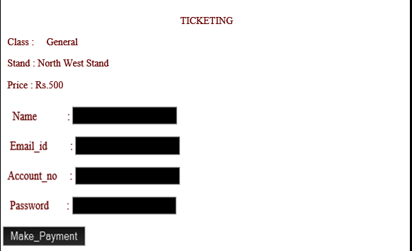

Also at the frontend various images and videos can be uploaded. The images uploaded must have the extension .png.

(5)
B. Backend tools
In a website there exists huge amount of data. Such data has to be maintained for proper and efficient access of data. Here we use the concept of database to store data .MySQL database is used to store
1.The user details.
2.The availability of seats.
3.The recent matches.
MySQL database is created using the XAMPP which provides a local server localhost. In XAMPP using phpMyAdmin databases are created and queries are written and verified. MySQL is similar to SQL ehich provides all the basic SQL constructs such as:
1.The SELECT clause.
2.The UPDATE clause.
3.The ORDER BY clause.
4.The WHERE clause.
5.ODBC
6.The DELETE clause.
7.The INSERT INTO command.
The queries written in MySQL can be converted into php which act as a backend for the website. This backend stores data in an organized manner.
PHP + MySQL acts as a cross platform which is an attribute conferred to computer software or computing methods and concepts that are implemented and inter-operate on multiple computer platforms. Cross-platform software may be divided into two types; one requires individual building or compilation for each platform that it supports, and the other one can be directly run on any platform without special preparation.

(6)
4. PROJECT DESCRIPTION

Cricket is one of the most loved sports in India. The website ‘Crickodile’ caters to needs of such cricket fans. The website is hosted on the local server which is created through XAMPP. The backend is managed through MySQL under the database name ‘Ticketing’. The database is managed through phpMyAdmin provided by XAMPP where queries are implemented and converted into an equivalent php code. The various unique features include statistics about various cricketing tournaments and the way in which young cricketing talent is cultivated in a country with such a vast population.
The ticketing forms the backbone of the website. Here the user books a ticket for the recent matches. This part extensively uses the frontend and the backend. The steps involved for ticketing are :

Steps | User’s point of view | Programmer’s point of view
1. | Create the user account and enter the banking information. | The account information is stored in the database of the customer.
2. | The user selects the class , stand , seat of the seating. | The database stores the class , stand , seat of seating selected by the user.
3. | The availability of the seat in the mentioned class and stand is checked. | A query is implemented which displays out the available seats for given class and stand.
4. | The user enters the information of the ticket holder and the account number. | The validity of the information entered by the user is checked.
5. | _ | If the information is valid then ticket is displayed.
6. | The user takes the print of the ticket which acts a confirmation of the transaction. | _

(7)
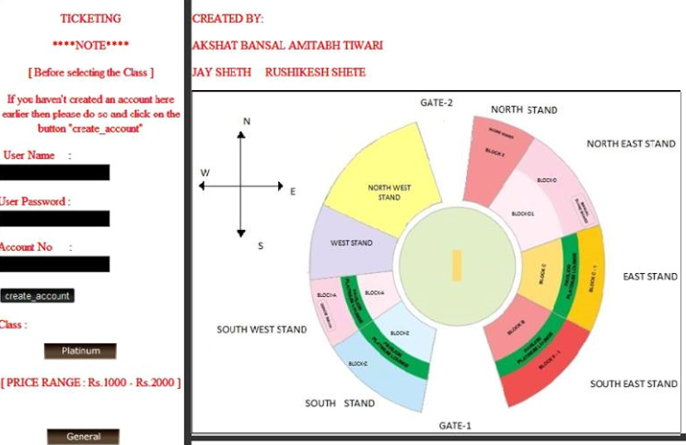
Info1.php Form that asks the user to enter the data and enter into the database.
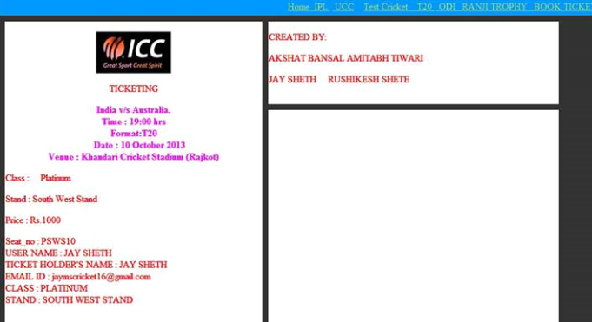
The confirmation that the transaction is complete.

(8)
5. SNAPSHOTS
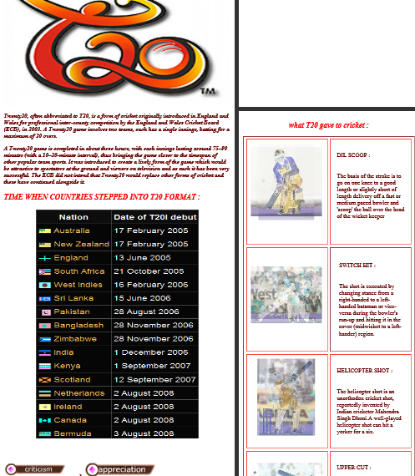 T20 Cricket

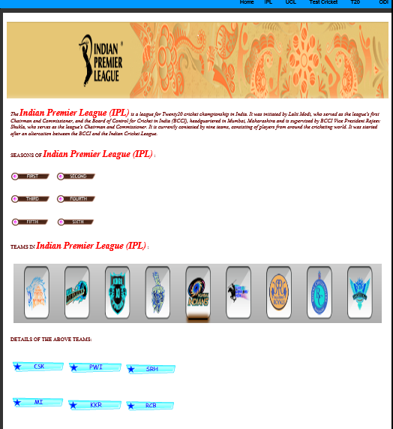IPL

(7)
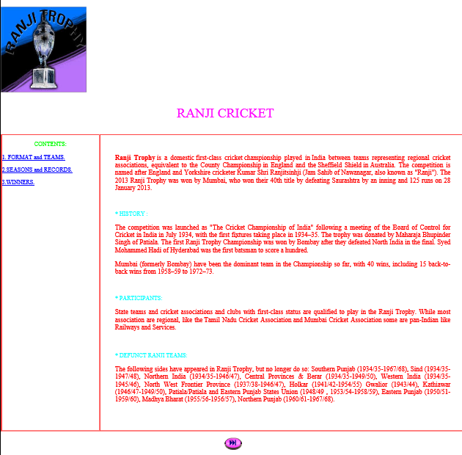

RANJI TROPHY

(9)
6. SOURCE CODE
//The following code asks user to create an account and then choose class. At the back-end level this //information is fed into the database so as to proceed with the transaction.The output is shown on pge //no.5(Front-end+Back-end)
<!DOCTYPE html PUBLIC "-//W3C//DTD XHTML 1.0 Transitional//EN" "http://www.w3.org/TR/xhtml1/DTD/xhtml1-transitional.dtd">
<html xmlns="http://www.w3.org/1999/xhtml">
<head>
<meta http-equiv="Content-Type" content="text/html; charset=iso-8859-1" />
<title>Untitled Document</title>

<link href="css.css" rel="stylesheet" type="text/css" />
<style type="text/css">
<!--
.style5 {
color: #00FFFF;
font-size: 24px;
}
.style6 {font-size: xx-large}
.style7 {font-size: 18px}
body,td,th {
color: #00FFFF;
}
#Layer1 {
position:absolute;
width:200px;
height:115px;
z-index:1;
left: 718px;
}
.style9 {font-size: 14px; color: #99FFFF; text-decoration: none; padding: 10px; font-family: "Times New Roman", Times, serif;}
body {
background-color: #CCCCCC;
}
-->
</style>
</head>

<body>
<table width="1024" height="1000" border="0" align="center" cellpadding="0" cellspacing="0">
<tr>
<td height="30" align="center" valign="middle" bgcolor="#000000" class="style5"><p>&nbsp;</p>
<p>&nbsp;</p>
<p class="style6">CRICODILE</p>
</td>
</tr>
<tr bgcolor="#FF6600">
<td height="30"><div align="right" class="link"><a href="home.php">Home</a><a href="../ipl.php">&nbsp; IPL </a>&nbsp;<a href="../ucl.php">&nbsp; UCL</a> &nbsp;&nbsp; <a href="../test_cri.php">Test Cricket </a><a href="../tty.php">&nbsp;&nbsp; T20</a><a href="#"> </a>&nbsp;<a href="../odi.php">&nbsp;ODI</a></div></td>
</tr><tr> (10)
<td><img src="" alt="" name="banner" width="4" height="0" id="banner" style="background-color: #0099FF" /></td>
</tr>
<tr>

<td><table width="94%" height="959" border="0" cellpadding="1" cellspacing="10" bordercolor="#FFFFFF">
<tr>
<td width="555" height="1084" rowspan="2" align="left" valign="top" bgcolor="#000000" class="foter"><p align="center"><img src="stadium/icc.jpg" alt="icc" width="128" height="72" /></p>
<p align="center">TICKETING</p>
<form id="form1" name="form1" method="post" action="ges_booked.php">
<p>
<label></label>
Class : &nbsp;&nbsp;&nbsp;&nbsp;General </p>
<p>Stand : East Stand
<p>Price : Rs.300
<p>Seat_no : <?php
$con=mysqli_connect("localhost","root","mumbaiindians","ticketing");
if(isset($_POST['Make_Payment']))
{
$user=$_POST["Name"];
$go="false";
$go1="false";
$all_users=mysqli_query($con,"select user_name from bank"); while($all_users1=mysqli_fetch_array($all_users))
{
if($all_users1["user_name"]==$user)
{
$go1="true";
}
}
if($go1=="true")
{
$go2="false";
$password1=mysqli_query($con,"select password from bank where user_name='$user'");
while($password2=mysqli_fetch_array($password1))
{
$check_password=$password2["password"];
if($check_password==$_POST["pass"])
{
$go2="true";
//echo "success g2";
}
}
if($go2=="true")
{
$acc_check1=$_POST['Account_no'];
$pass_check2=$_POST['pass'];
$user=$_POST["Name"];
$acc1=mysqli_query($con,"select acc_no from bank where user_name='$user'and password='$pass_check2'");
while($acc=mysqli_fetch_array($acc1))
{
if($acc["acc_no"]==$acc_check1)
{
(11)
//echo "acc";
$go="true";
}
}
if($go=="true")
{
$acc_check1=$_POST['Account_no'];
$bal=mysqli_query($con,"select balance from bank where acc_no='$acc_check1'");

while($c_bal=mysqli_fetch_array($bal))
{
$curr_bal=$c_bal["balance"];
if((int)$curr_bal>=300)
{
$upd=mysqli_query($con,"update bank set balance=balance-300 where acc_no='$acc_check1'");
$t=mysqli_query($con,"select seat_no from booked");
while($t1=mysqli_fetch_array($t))
{
//echo "success";
echo $t1["seat_no"]." ";
$t2=$t1["seat_no"];
$w_ins=mysqli_query($con,"insert into booked_ges (seat_no) values ('$t2')");
$s1=mysqli_query($con,"INSERT INTO user_info_ges (Name,Email_id,Stand,seat_no,Class) VALUES ('$_POST[Name]','$_POST[Email_id]','East Stand','$t2','General')");
$w_rem=mysqli_query($con,"delete from booked where seat_no='$t2'");
echo "<br>";
echo "USER NAME : ".$_POST["Name"]."<br>";
echo "TICKET HOLDER'S NAME : ".$_POST["ticketholder"]."<br>";
echo "EMAIL ID : ".$_POST["Email_id"]."<br>";
echo "CLASS : GENERAL <br>";
echo "STAND : EAST STAND <br>";

}

}//end of while if
else
{
echo "Insufficient balance to buy ticket-->";
$t=mysqli_query($con,"select seat_no from booked");
while($t1=mysqli_fetch_array($t))
{
echo $t1["seat_no"]." ";
$t2=$t1["seat_no"];

$w_rem=mysqli_query($con,"delete from booked where seat_no='$t2'");
}
}//end of while else
}//end of outer while
}//end of outer if

if($go=="false")
{

echo "Wrong account no.Cannot allocate you the ticket--> ";
(12)
$t=mysqli_query($con,"select seat_no from booked");
while($t1=mysqli_fetch_array($t))
{
echo $t1["seat_no"]." ";
$t2=$t1["seat_no"];

$w_rem=mysqli_query($con,"delete from booked where seat_no='$t2'");
}

} //end of else[i.e account no is wrong]

}//end of if($go2==true)

if($go2=="false")
{

echo "Wrong password.Cannot allocate you the ticket--> ";
$t=mysqli_query($con,"select seat_no from booked");
while($t1=mysqli_fetch_array($t))
{
echo $t1["seat_no"]." ";
$t2=$t1["seat_no"];

$w_rem=mysqli_query($con,"delete from booked where seat_no='$t2'");
}

}//end of password check

}//end of if($go1==true)

if($go1=="false")
{

echo "Wrong user name.Cannot allocate you the ticket--> ";
$t=mysqli_query($con,"select seat_no from booked");
while($t1=mysqli_fetch_array($t))
{
echo $t1["seat_no"]." ";
$t2=$t1["seat_no"];

$w_rem=mysqli_query($con,"delete from booked where seat_no='$t2'");
}

}// end of user name check

}//end of isset
mysqli_close($con);

?>
<p>
<p>
(13)
<label></label>
<p>
<label></label>
</p>
</form>
</td>
<td width=”671” height=”139” align=”left” valign=”top” bgcolor=”#000000”><div align=”left”>
<p class=”style3”>CREATED BY:</p>
<p class=”style3”>AKSHAT BANSAL AMITABH TIWARI</p>
<p><span class=”style3”>JAY SHETH &nbsp; &nbsp; RUSHIKESH </span><span class=”style3”>SHETE</span> &nbsp; &nbsp;</p>
</div>
</td>
</tr>
<tr>
<td height=”790” align=”left” valign=”top” bgcolor=”#000000”><p align=”center”>&nbsp;</p>
<p align=”center”>&nbsp;</p>
<p align=”center”>&nbsp;</p></td>
</tr>
</table></td></tr>
<tr>
<td bgcolor=”#000000” class=”foter”><div align=”center”><!-- #BeginLibraryItem “/Library/foter.lbi” →copyright &copy; 2013. &nbsp;&nbsp; 18rocodile.com <!-- #EndLibraryItem →</div></td>
</tr>
</table>
</body>
</html>

(14)
7. FUTURE SCOPE

- The website developed is on a localhost , that is all the web pages that are accessed , must have their source codes locally on the machine, from which data is requested. The most important development in the project will be to make this data available globally via a proper domain name.
- The ‘Live Score’ feature is omitted from this website which can be included to give the end user the live updates of the game with commentary.
- The online shopping feature for various cricketing accessories can be included which will involve the creation of user accounts with proper security and linking of accounts to the available accessories and new developments in the sports.
- The ticketing performed assumes that one person can buy only one ticket. This can be further improved by allowing one user to book multiple tickets which would be booked in continuous manner.
- The ticketing can be further improved by creating realistic views of different stadium across the country. In the current model we have a reference stadium according to which booking is done. Also cancellation of tickets can be included.

(15)
7. CONCLUSION
The cricketing website ‘Crickodile’ is developed with the front end and back end being php and MySQl. The various features such as the following make it unique in its own way :
- All cricketing action under one roof.
- Ticket booking for recent matches.
- The user has the flexibility to choose the seat during ticketing.
- Stadium outline is provided for easier selection of seats.
- Systematic display of facts for easier access.
- Convenient access to Indian cricket: its varied forms and diverse culture to cultivate the talent among young cricketing fans.

(16)

8. BIBLIOGRAPHY

- www.apachefriends.com
- www.w3schools.com
- www.wikipedia.org
- www.bitnami.com
- www.mysql.com
- PHP and MySQL Web Development [Luke Welling and Laura Thomson – Fourth edition]

(17)

